Dynamic Model of a Scara Robot.

Hernández, C; Mena, J; Gutiérrez, S; Ríos, Y;

*Instituto Tecnológico de Toluca  
Robótica, grupo 19040, Equipo #9*M. Sc. Carlos Alberto Sánchez Delgado

Abstract—

In this Project we are going to develop the dynamic model of a Scara robot which has 4 degrees of freedom. And then, we will apply all the values calculated to a basic model CAD of a Scara robot, these will be obtained by the manipulation of the CAD model. Then, with a Python program we will find numeric values to get real data about this model. International System units will being use in this project. As a final product, we obtain the tensorial form of the dynamic model and the numeric values according to our CAD model.

1. Introduction

This document presents the necessary calculations to obtain the dynamic model of a Scara robot in its tensor form. This was done for the subject of "robotics" in the Mechatronic Engineering career at the "Instituto Tecnológico de Toluca" as part of the final evaluation. And we as members of the team made the effort to present this material in English, being that we are native Spanish speakers, in order to obtain greater dissemination within the internet communities that talk about topics like this.

There is a basic CAD model of a Scara robot, with which we are going to evaluate the values, obtained by software (such as moments of inertia, distances, etc.), for the result, to have a complete dynamic model of the entire robot with these specific values.

As research methodology used in this work, the quantitative methodology of the mathematical model was used.

As a limitation in the understanding of this project, we have the need that the reader must previously know several concepts for a good understanding; these concepts are mostly from physics and linear algebra.

In this first stage, the "FreeCAD" software will be used, but its use can be extrapolated to any other CAD software that has the necessary tools.

1. Dynamic model
2. **Scara diagrams.**

First thing is first. The Scara robot diagrams that represent its position within a reference frame, in order to have the necessary references to make the necessary calculations. These diagrams are presented in Fig. 1 and Fig. 2.

Fig. 3D diagram of Scara robot

Fig. 2D diagram of Scara robot (top view)

1. **Position vectors of centers of mass**

To calculate the position vectors of each center of mass of our robot, we will consider the structure what is seen in the Fig. 1 and Fig. 2. It is important to mention that since links 3 and 4 of our Scara are mechanically interlocked, it is being considered that both links share the same center of mass. Then, the position vectors result as shown in ( 43).

|  |  |
| --- | --- |
| Note: could exist or not and is the distance between the center of mass of linkage 1 and the linkage 2’s one. | ( 1) |

1. **Kinetic Energy**

To calculate the Kinetic Energy, we need to work something about its definition ( **2**).

**Definition:**

|  |  |
| --- | --- |
|  | ( 2) |

But we will change something, we will use the definition of the inertia tensor relative to an inertia frame

Then, the definition of is like appears in ( **3**).

|  |  |
| --- | --- |
|  | ( 3) |

We are going to use ( **43**) to calculate its values ​​for each link of the robot, but we are going to calculate each component of this equation separately, so that it is easier to transcribe all the equations during the process.

1. **Kinetic energy for each linkage.**

**Important:** We can see that the sine and cosine functions are involved in the position vectors of the centers of mass; Since from now on the results will become extensive, we are going to reduce the expressions sine and cosine to an S and a C respectively, each one followed by a subscript that alludes to the angle of theta that they have as argument. If there are two numbers in the subscript, a sum of those angles is being indicated in the function argument.

1. Linkage 1

|  |  |
| --- | --- |
|  | ( 4) |
|  | ( ) |

Then, for linkage 1; we must add ( **4**) and ( 5), so we obtain ( **6**).

|  |  |
| --- | --- |
|  | ( 6) |

1. Linkage 2

|  |  |
| --- | --- |
|  | ( 7) |

( **7**) has a very large result, but it can be reduced to get what is showed in ( **8**).

|  |  |
| --- | --- |
|  | ( 8) |

For previous experience, we know how the structure of the result is, so we do not see mandatory to write all the body of the equation ( **9**).

|  |  |
| --- | --- |
|  | ( 9) |

Then, for linkage 2; we must add ( **8**) and ( **19**), so we obtain ( **10**)( **43**).

|  |  |
| --- | --- |
|  | ( 10) |

1. Linkage 3

|  |  |
| --- | --- |
|  | ( 11) |

Note: was derivate because it is a variable; we must remember that there is a prismatic joint in our robot, and that defines de value of .

We can see the result of solve ( **11**) in ( 13).

|  |  |
| --- | --- |
|  | ( 12) |
|  | ( ) |

We must remember that links 4 and 3 are mechanically coupled; and since link 4 presents a rotational movement, this rotation influences the angular velocity of link 3.

|  |  |
| --- | --- |
|  | ( 14) |

If links 3 and 4 are mechanically coupled; these last equations are valid for both links.

1. **Potential Energy for each linkage**

The definition of potential energy for the linkage i is presented in ( **15**).

|  |  |
| --- | --- |
|  | ( 15) |

Where:

-> Force of gravity

-> Distance between the center of mass of the link and the XY plane, measured through the Z axis.

1. Linkage 1

|  |  |
| --- | --- |
|  | ( 16) |

1. Linkage 2

|  |  |
| --- | --- |
|  | ( 17) |

1. Linkage 3

|  |  |
| --- | --- |
|  | ( 18) |

1. **Total kinetic energy**

Now, to obtain the total energies, we must add everything obtained in each link in a single equation.

|  |  |
| --- | --- |
|  | ( 19) |

1. **Total potential energy**

|  |  |
| --- | --- |
|  | ( 20) |

1. **Lagrange**

In ( **21**) we presented the result with all the reductions that can be applied without making more difficult the next steps.

|  |  |
| --- | --- |
|  | ( 21) |

1. **Euler-Lagrange equation (motion equation)**

The Euler-Lagrange equation is showed in ( **22**).

|  |  |
| --- | --- |
|  | ( 22) |

So, we must calculate equation ( **22**) at each link to obtain the equation of the minimum torque needed to move the link

1. Linkage 1

|  |  |
| --- | --- |
|  | ( 23) |
|  | ( ) |
|  | ( ) |

1. Linkage 2

|  |  |
| --- | --- |
|  | ( 26) |
|  | ( ) |
|  | ( ) |

1. **Linkage 3**

We must consider two variables for this link, and , so we have two sections here.

|  |  |
| --- | --- |
|  | ( 29) |
|  | ( ) |
|  | ( ) |
|  | ( ) |

|  |  |
| --- | --- |
|  | ( 33) |
|  | ( ) |
|  | ( ) |
|  | ( ) |

1. **Tensor form of the equation of motion**

For this robot, the tensor form of the equation of motion is provided in ( **43**). But as we have seen, we have torque equations with very long coefficients, therefore we are going to give the value of each coefficient of the matrix independently at the bottom of the matrix.

|  |  |  |  |  |  |  |  |
| --- | --- | --- | --- | --- | --- | --- | --- |
| Note: We must take care about all the numbers that participates in each element of the torque equations. At this point is too easy get a mistake.  MASS MATRIX   |  |  | | --- | --- | |  | ( 37) |   KINETICS MATRIX   |  |  | | --- | --- | |  | ( 38) |   GRAVITIES MATRIX   |  |  | | --- | --- | |  | ( 39) | | ( 40) |

1. **Application to the dynamic model to a Scara CAD model**

We have a Scara robot model made with CAD software (Fig. 3); We are going to open the files of each of the links of the robot to be able to calculate the values ​​relative to their physical properties.

Fig. Scara CAD model

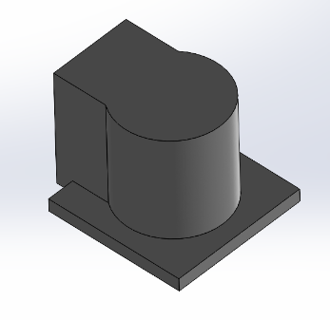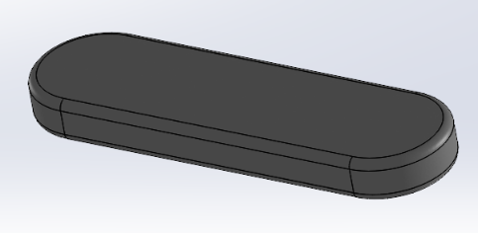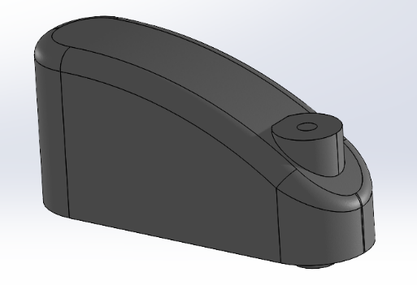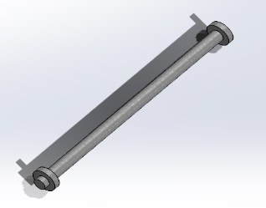

First, we are going to modify a material to assign it to all the links; The property that we are going to pay attention to is the density, which should be 1 g/cm^3. This change to a material in Solid Works (SW) is showed in Fig. 4.

Fig. Material density modification

Once this material has been assigned, we are going to collect the necessary data regarding the physical properties of each link.

Fig. Mass properties for base

Fig. Mass properties for linkage 1

Fig. Mass properties for linkage 2

Fig. Mass properties for linkage 3

Then we have the following values:

|  |  |
| --- | --- |
|  | ( 41) |

In order to obtain the distances at which the centers of mass are from each other in SW as shown in Fig. 9.

Fig. Measurement of the distances between the mass centers

Then we have the following values:

|  |  |
| --- | --- |
|  | ( 42) |

For use the mathematical model, we will use all the elements of mass and distances and, we will set the following values:

|  |  |
| --- | --- |
|  | ( 43) |

We build a Python class that is capable to compute the values for each coefficient of the tensor form of equation of motion. And if we use all the data that we mentioned before, we will get the results that appears in Fig. 10.

Fig. Python module results

Then, these are the coefficient values ​​that when substituted in the tensor form, we can obtain the required torques for the proposed position and angular velocity restrictions. The python module that was used to find the values ​​of these coefficients is made in such a way that different values ​​can be entered into it for different measures and different constraints. In this way, the application becomes more global if the Scara robot meets the characteristics of the one used for this project. The source code of the module will be available in the attachments section.

1. Conclusions

* Gutiérrez Sánchez Sergio: With the development of this work I have learned a lot and above all seen how to develop and carry out all the mathematical modeling of a robot, which is an extremely complex system and that considers many areas of knowledge, for which, in addition to the results obtained, I can affirm which is one of the broadest subjects as far as this career is concerned, since we cover everything, from algebra, calculus, differential equations, linear algebra, to classical mechanics. All of this, in order to have exactly what we learned to develop, our robot, which, as I already mentioned, is a very extensive practice and it helped us a lot to learn to apply everything we have already seen in class.
* Hernández Villanueva Cristian Saúl: From this project I can conclude that doing the mathematical modeling of a system as complex as a robot is a great way to develop skills related to many areas of knowledge, since many concepts must be used, and many things applied in order to find a solution to the problem. issue. I can also conclude that a balance between the theoretical and the practical part should be fostered; because applying mathematical modeling to this robot has been a very good practice to see what the first steps of the complete design of a robot are.
* Mena Huerta José Manuel: In this last evaluation of the robotics subject with the development of the dynamic model of a SCARA robot we make use of all the knowledge seen in the course and in previous subjects, from working with the direct kinematics of the system to the calculation of all the forces using Lagrange and its principle of least action, taking into account the kinematic and potential forces of the whole body as well as of each joint, having the just difficulty to evaluate this subject.
* Ríos Martínez Yessica Yamiled: With what I have done in the previous project I can conclude that I am more than satisfied with what I have learned, since knowing how to perform and more than anything understand how is the execution of the theoretical and practical part of a robot gives me a broad overview to see that it is not as complicated as it seems, being interested in wanting to know more about the areas in which I can apply this knowledge and carry out subsequent projects, since we have the necessary bases of the Robotics subject in relation to what I learned throughout the university

1. Attachments

GitHub Repository:

<https://github.com/JellyfishDotcom/Dynamics_Scara>